Wetzel-Tyler Health Department
425 South Fourth Avenue
Paden City, WV 26159
(304) 337-2001 fax (304) 337-2004

David Hess, MD, Health Officer
Ashley Guiler, BSN, RN, Administrator
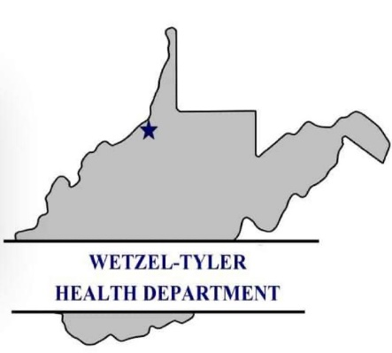

Wetzel Tyler Health Department
In-School Vaccine Event
Wetzel Tyler Health Department will be holding a School Vaccine event at Wetzel County Schools:
Wednesday, April 19 Thursday, April 27
HHS 10am NMS 9:30am
LDS 11am MHS 10:30am
VHS 1pm PCES 1pm
SLS 2pm PCHS 2pm
To better serve our schools, WTHD has partnered with Tyler County Schools to provide better access to school required vaccines. WTHD will be holding an in-school clinic to provide the WV State required vaccines to your child. Participation in the vaccine clinic is voluntary. You may choose to have your child vaccinated at your family physician before the 2023-2024 school year. No grace period will be offered for the unvaccinated once the school year commences. Any student that is not up to date on required vaccines will not be permitted to attend sports practice (1st date of practice in the fall).

Below are the required vaccines per age and grade:
7th Grade  (recommended at age 11) | 12th Grade  (recommended at age 16)
Meningitis ACWY-1 dose  Tetanus, Diptheria, Pertussis (TDaP)-1 dose | Meningitis ACWY #2
Included in this packet are the Center for Disease Control’s Vaccine Information Statements that fully explain each vaccine in detail. Any questions regarding these vaccines can be answered by calling WTHD @ 337-2001. You can also accompany your child during the event. Please take advantage of this service.

Please fill out the Vaccine Consent Form and send back to the school no later than April 1.

